UNIT 10: OUR HOUSES IN THE FUTURE
LESSON 1. GETTING STARTED
Practice | Name: | Class: | Score:
Odd one out
- A. cottage B. apartment C. washing machine D. villa
- A. microwave B. dishwasher C. fridge D. stilt house
- A. wireless TV B. houseboat C. palace D. skyscraper
- A. village B. balcony C. city D. countryside
- A. bedroom B. computer C. living room D. kitchen
Choose the best answer
1. 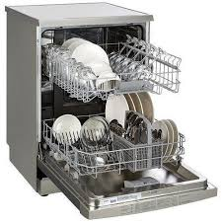 | a. dishwasher  b. washing machine  c. microwave  d. kettle | 2. 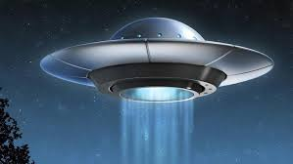 | a. hi-tech robot  b. computer  c. UFO  d. wireless TV
3. 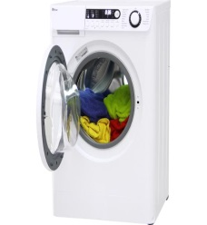 | a. stove  b. fridge  c. washing machine  d. vacuum cleaner | 4. 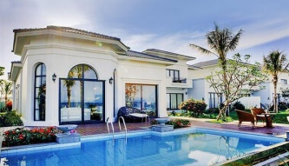 | a. apartment  b. cottage  c. stilt house  d. villa
5. 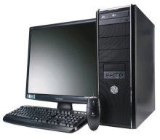 | a. television  b. computer  c. hi-tech robot  d. closet | 6. 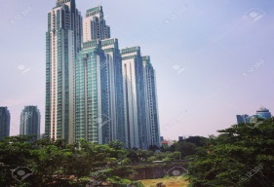 | a. skyscraper  b. apartment  c. houseboat  d. motorhome
7. 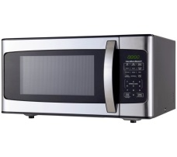 | a. cooker  b. microwave  c. air conditioner  d. iron | 8. 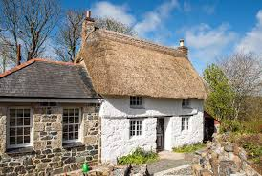 | a. houseboat  b. skyscraper  c. palace  d. cottage

Write a letter (A-H) next to each sentence
A. microwave | B. fridge | C. hair dryer | D. lamp
E. stove | F. washing machine | G. television | H. dishwasher

1. This is an appliance which is used to wash your clothes. ………….
2. This machine washes your plates, glasses and other kitchen equipment. ……………
3. This piece of electrical equipment is used to dry your hair. ……………..
4. It is an electric oven. It uses waves of energy to heat food. …………….
5. This is a large container. It keeps your food and drinks cold. ……………
6. This is in the shape of a box. It’s got a screen on the front. ……………..
7. When it is dark, you turn on this equipment. ……………….
8. You use this to cook your food. ………………

Choose the correct preposition in brackets to complete the sentences.
1. Our future houses might be _______ the ground. (at/ under/ to)
2. He wishes that he will have a villa _______ the sea. (by/ of/ above)
3. This car runs _______ electricity, so we don’t use gas. (for/ with/ on)
4. He doesn’t want to live _______ the city when he grows up. (of/ in/ to)
5. I can order food from a restaurant while I’m _______ home. (on/ in/ at)
6. Will robots help us _______ the household chores? (on/ for/ with)
7. I think all my dreams will come true _______ the future. (in/ to/ of)
8. Do you think there is life _______ other planets? (above/ on/ at)

Put the words into the correct column.
smartphone address cottage guitar birthday
poster resort forest routine ocean
alarm heater success villa disease
First-stressed syllable | Second-stressed syllable
Choose the word whose stress pattern is different from the others.
1. A. famous B. police C. device D. machine
2. A. receive B. complete C. perform D. gather
3. A. helpful B. flower C. about D. wireless
4. A. happen B. hotel C. visit D. bathroom
5. A. event B. market C. water D. garden

Circle the best word
- We often watch T.V and eat popcorn in the living room/kitchen.
- He hangs a beautiful picture/map on the wall in the sitting room.
- Our grandparents live in a small house in the apartment/village.
- The house/bedroom has got a fireplace and a spacious balcony.
- He always waits for me at the front door/window with his arms open.
Match the verbs in A with the nouns in B.
A |  | B
- wash |  | - the housework
- clean |  | - the plants
- fix |  | - dinner
- send |  | - the television
- cook |  | - the phone
- answer |  | - the dishes
- take care of |  | - an email
- surf |  | - the house
- water |  | - the internet
10.do |  | j. the baby

Choose the best answer to complete the sentences.
1. He lives in _______ because he likes farming work.
A. the sea B. the countryside C. space D. the city
2. Hi-tech _______ might help mothers to look after children.
A. computers B. robots C. smartphones D. machines
3. Besides storing foods, a modern _______ can cook meals.
A. washing machine B. dishwasher C. fridge D. wireless TV
4. Wind flowing from a ceiling _______ can make the whole room cool and airy.
A. fridge B. electric cooker C. electric fan D. smart clock
5. I usually _______ the dishes after dinner.
A. cook B. wash C. help D. water
6. _______ will help us watch TV programmes from space.
A. Smart clock B. Robot C. Wireless TV D. Super car
7. Here, you can enjoy the _______ view and dive into the turquoise water.
A. hill B. city C. park D. sea
8. Mrs. Nina is cooking dinner in the _______ now.
A. kitchen B. bathroom C. bedroom D. living room
9. We might live in a comfortable _______ on the Moon.
A. supermarket B. apartment C. garden D. school
10. I can wash all my dirty clothes with the help of the _______.
A. dishwasher B. wardrobe
C. cupboard D. washing machine

Choose the best answer to complete the sentences.
1. Happy new year! Wishing that we _______ healthy and happy.
A. will be B. are C. were D. might be
2. Michael _______ having a robot at home, but his father _______.
A. mightn’t mind - doesn’t mind B. might mind - don’t mind
C. might mind - might mind D. mightn’t mind - minds
3. We _______ a hi-tech house next year, and it _______ in the city.
A. won’t buy - will be B. buy - won’t be
C. will buy - will be D. don’t buy - will be
4. She _______ send me emails, but she _______ call me directly.
A. might - might B. will - will
C. mightn’t - won’t D. mightn’t - might
5. Julia _______ get there in time, but I _______ be sure.
A. might - can’t B. might - can C. will - can D. won’t - can’t
6. There _______ be a helicopter on the roof so I _______ fly to school.
A. won’t - can B. can’t - might C. will - can D. mightn’t - will
7. _______ modern robots _______ the chores? - Yes, they _______.
A. Will... do - do B. Will... do – will
C. Do ... do - will D. Will... do - won’t
8. She _______ a few ideas about what she _______ in the future, but nothing definite.
A. have - will do B. have - does C. has - might do D. has - do
9. _______ houses in the future _______ the environment? - Yes, they _______.
A. Will... protect - will B. Does ... protect - will
C. Does ... protect - don’t D. Will... protect - do
10. _______ Mr. Henry _______ a white fence for his garden? - No, he _______.
A. Does ... builds - doesn’t B. Will... build - won’t
C. Do ... build - do D. Will... build - doesn’t

Choose the word or phrase that needs correcting.
1. Bring a raincoat because it might to rain today!
A B C D
2. Everyone believes that Josh stays at home all day tomorrow.
A B C D
3. What type of house you will live in the future ?
A B C D
4. Linda doesn’t have a map, so she might find our house.
A B C D
5. I think my future house will be on the mountains.
A B C D

Complete the second sentence so that it means the same as the first one.
1. There will be about twenty rooms in their dream palace.
Their dream palace will
2. I’m not sure about living in an apartment in a skyscraper.
I mightn’t
3. Please help me arrange the furniture!
Will you ?
4. They will probably stay with us in a guest house.
They might
5. We mightn’t see them at the weekend.
Perhaps we won’t

ANSWER KEYS
Odd one out
A. cottage |  |  | B. apartment |  |  |  |  |  |  |  | C. cooker |  |  |  |  |  | D. villa
A. microwave |  |  | B. dishwasher |  |  |  |  |  |  |  | C. fridge |  |  |  |  |  | D. apartment
A. television |  |  | B. houseboat |  |  |  |  |  |  |  | C. palace |  |  |  |  |  | D. villa
A. village |  |  | B. balcony |  |  |  |  |  |  |  | C. city |  |  |  |  |  | D. countryside
A. bedroom |  |  | B. computer |  |  |  |  |  |  |  | C. living room |  |  |  |  |  | D. kitchen

Choose the best answer
 | 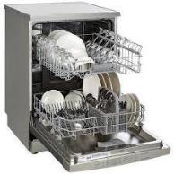 |  |  |  |  | a. |  | dishwasher |  |  |  |  |  | 2. |  | a. hi-tech robot
 |  |  |  |  |  | b. washing |  |  |  |  |  |  |  |  |  | b. computer
 |  |  |  |  |  | machine |  |  |  |  |  |  |  |  |  | c. UFO
1. |  |  |  |  |  | c. microwave |  |  |  |  |  |  |  | 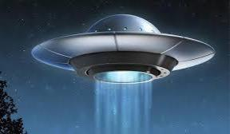 |  | d. wireless TV
 |  |  |  |  |  | d. kettle
 | 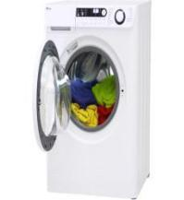 |  |  |  |  | a. stove |  |  |  |  |  |  |  | 4. |  | a. apartment
 |  |  |  |  |  | b. fridge |  |  |  |  |  |  |  | 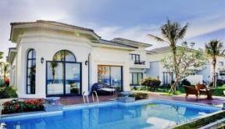 |  | b. cottage
 |  |  |  |  |  | c. washing |  |  |  |  |  |  |  |  |  | c. stilt house
3. |  |  |  |  |  | machine |  |  |  |  |  |  |  |  |  | d. villa
3. |  |  |  |  |  | d. vacuum cleaner
 |  |  |  |  |  | a. television |  |  |  |  |  |  |  | 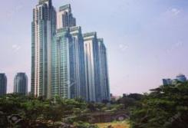 |  | a. skyscraper
 |  |  |  |  |  | b. computer |  |  |  |  |  |  |  |  |  | b. apartment
5. |  |  |  |  |  | c. hi-tech robot |  |  |  |  |  |  |  | 6. |  | c. houseboat
5. |  |  |  |  |  | d. closet |  |  |  |  |  |  |  | 6. |  | d. motorhome
 |  |  |  |  |  | a. cooker |  |  |  |  |  |  |  |  |  | a. houseboat
 |  |  |  |  |  | b. microwave |  |  |  |  |  |  |  |  |  | b. skyscraper
7. |  |  |  |  |  | c. air conditioner |  |  |  |  |  |  |  |  |  | c. palace
7. |  |  |  |  |  | d. iron |  |  |  |  |  |  |  | 8. |  | d. cottage
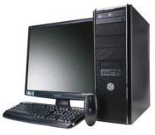
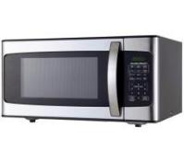
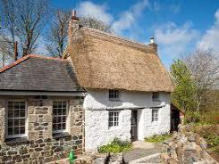

Write a letter (A-H) next to each sentence
A. microwave | B. fridge | C. hair dryer | D. lamp
E. stove | F. washing machine | G. television | H. dishwasher
- This is an appliance which is used to wash your clothes. F
- This machine washes your plates, glasses and other kitchen equipment. H
- This piece of electrical equipment is used to dry your hair. C
- It is an electric oven. It uses waves of energy to heat food. A
- This is a large container. It keeps your food and drinks cold. B
- This is in the shape of a box. It’s got a screen on the front. G
- When it is dark, you turn on this equipment. D
- You use this to cook your food. E

Choose the correct preposition in brackets to complete the sentences.
1. under 2. by 3. on 4. in 5. at 6. with 7. in 8. on

Put the words into the correct column.
- First-stressed syllable: smartphone, cottage, birthday, poster, forest, ocean, heater, villa
- Second-stressed syllable: address, guitar, resort, routine, alarm, success, disease
Choose the word whose stress pattern is different from the others.
l. A 2. D 3.C 4. B 5. A
Circle the best word
- We often watch T.V and eat popcorn in the living room/kitchen.
- He hangs a beautiful picture/map on the wall in the sitting room.
- Our grandparents live in a small house in the apartment/village.
- The house/bedroom has got a fireplace and a spacious balcony.
- He always waits for me at the front door/window with his arms open.
Match the verbs in A with the nouns in B.
1. F 2. H 3. D 4. G 5. C 6. E 7. J 8. I 9. B 10. A

ANSWER KEYS
Choose the best answer to complete the sentences.
1. B 2. B 3.C 4. C 5. B 6. C 7. D 8. A 9. B 10. D
Choose the best answer to complete the sentences.
1. A 2. D 3.C 4. D 5. A 6. C 7. B 8. C 9. A 10. B
Choose the word or phrase that needs correcting.
1. D (rain) 2. B (will stay) 3. B (will you live) 4. C (mightn’t) 5. C (in)
Complete the second sentence so that it means the same as the first one.1. Their dream palace will have about twenty rooms.
2. I mightn’t live in an apartment in a skyscraper.
3. Will you help me arrange the furniture (please)?
4. They might stay with us in a guest house.
5. Perhaps we won’t see them at the weekend.

